Title: MTP themes of discussion
Subject: MTP 11

1. Active vs Passive policy  2. Conducting Policy by rule vs Discretion | Should MP be active or passive?  A. Advocates of active policy  ‘Economy as subject to frequent shocks that lead to unnecessary fluctuations in gdp/u unless monetary or fiscal policies respond  believe that economic policy has been successful in stabilizing the economy’  B. Advocates of passive policy  ‘Monetary and fiscal policies work with long and variable lags, thus attempts to stabilize the economy often end up being destabilizing + our understanding of the economy is too limited to be useful in formulating successful stabilization policy’  Two main lags:  a. Inside lag: it takes time for policy makers first to recognize that a shock has occurred and then put appropriate policies into effect  b. Outside lag: time between a policy action and its influence on the economy  Actually we do not know much and we are really bad at fostering.  So if we want to adopt active policy we need to move in advance, hence to predict accurately future economic conditions.  We are so bad at predicting  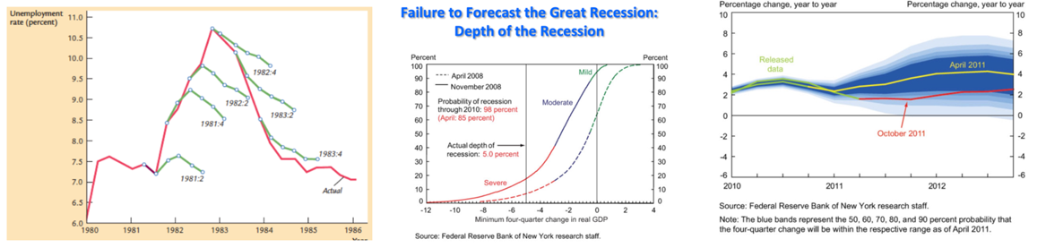  Moreover: market forecasts (SPF) differ from CB ones  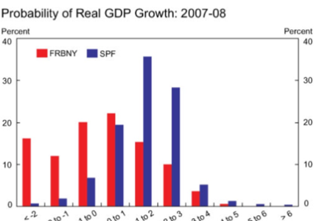  we failed in predicting 2008  I. Misunderstanding of the housing boom  II. We did not understand MBs  III. Insufficient weight given to the powerful adverse feedback loops between the financial system and the real economy  IV. The biggest failure was complacency (resulting from the apparent ease of maintaining financial and economic stability during the Great Moderation*): between 1990 and 2008 GDP and Inflation volatility plummeted, it was a period incredibly stable. Why? Three hypotheses: 1. Structural change (not really), 2. Good luck (probably), 3. Good policy  The Lucas critique: a simple intuition on why we are so bad at predicting  Many relationship among variables are not valid per se, but depend on policies. If policies change relationships change. Imagine that irrespective to criminal rate jewelries are never robbed bc each jewelry has 10 armed guards h24, does this mean there is no correlation between criminal rate and jewelries being robbed? If the policy changes (no more guards) there will be correlation.  Economic example: PC output-inflation relationship may be subject to changes in policies or cost of disinflations: Historical estimates of the cost of disinflations in terms of output are very large. These estimates are unreliable because they are subject to the Lucas critique. Such relations cannot be considered structural, as policy intervention may affect their key parameters. Solution: you have to write a model where parameters are really structural (do not depend on policy interventions) --> Go to microeconomics (ex. consumer preferences). An econometric model must be built at a deep enough level.  Rule: policymakers announce in advance how policy will respond to the state of the economy and commit to this announcement  Discretion: policymakers are free to evaluate the state of the economy at each time and choose policy appropriate at that time  Note: policy can be conducted by rule, and yet be either passive or active --> Passive rule: Money growth = 3% or Active rule: Money growth = 3% - output gap.  Why we like rules  a. Distrust of policymakers and political process (Incompetence, they make mistakes)  b. Time inconsistency: politicians like ST benefit vs LT cost (Opportunism). Ex. CB convinces everyone that inflation will be at 1%, expectations are formed. If suddenly it announces higher inflation creates huge ST output increase CB has incentive to deviate (but would lose credibility).  Rule vs Discretion general exampe  Ex. rule: no negotiation with hostages. We know politicians in the SR will want to negotiate, but as terrorists know this they would have an incentive to kidnap (know they will be paid).  Outcome: easier to achieve goals under commitment than under discretion  Rules vs Discretion in our model  assume π* = 0 for simplicity  a. Discretion  Assume x*(TARGET OUTPUT) > 0 --> CB wants output higher than natural level. Thus increases inflation more than expected.  Consider the PC-MPR equilibrium (CB Loss fucnt opt given state of the econ)  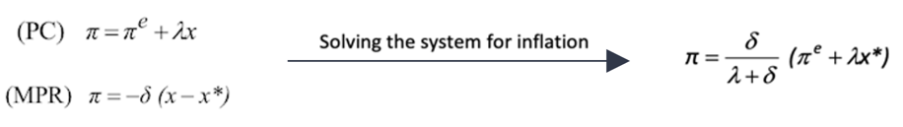  In the LR:  Agents raise their inflationary expectations (PC shifts up) --> In the long run it must be π = π^{e}  --> π = δx*  BUT Substituting π* into MPR we get x = 0  KEY: THEY TARGET POSITIVE x* BUT THEY GET x = 0  *the same result can be obtained from the PC simply by noting that as long as inflation expectations are correct the output the output gap cannot deviate from 0  b. Rule  π^{e} = π = π * --> x*= 0  Lower inflation without lower output if CBs commit to a policy of low inflation. Rule solves time inconsistency problem

